# Frequently Asked Questions

What Product Categories are available to purchase?  
Through Amazon Business you will have access to all items available on the standard Amazon.com site, plus additional business-specific items and millions of items offering lower business pricing and quantity discounts. Amazon Business offers a wide variety of products and has been added in order to **supplement the existing University-wide contracts** already in place. Categories available through Amazon Business include the following:

|  |  |
| --- | --- |
| Books | Classroom, School, Art Supplies |
| Sports & Outdoor Recreation | Musical Instruments |
| Mechanical and Industrial Supplies and Tools | Teaching/School Supplies & Equipment |
| Safety Supplies | Miscellaneous Items |

You will notice when accessing Amazon Business through eCUBE that additional product categories are available in addition to the ones listed above**. As the University has existing University-wide contracts for many of these additional categories, we have restricted these categories from being ordered through Amazon.** If you select an item in one of the restricted categories, you will see a message above the item stating that the item is restricted, and **you must not select that item or add it to your cart**. The following are restricted Amazon Business categories: Apparel, Computers, Electronics & Supplies, Furniture & Furnishings, Gift Cards, Office Supplies, Promotional Items, Scientific & Lab Supplies, and Scientific & Medical Chemicals. The entire list of contracted vendors and categories is available at [University Contracted Vendors](https://cms.ysu.edu/administrative-offices/procurement-services/procurement-vendor)

Can I use my PCard to purchase from Amazon?No. Now that Amazon Business is enabled in eCUBE, all purchasing must be done in eCUBE.

Can I use the YSU Amazon Business account for personal use?No. The central YSU Amazon Business Account **must be used for business purchases only**, in accordance with our purchasing policies. The YSU purchasing team will have access to all purchasing history made through the centralized Amazon Business account.

I already use my @ysu.edu email address to make PERSONAL Amazon.com purchases. If your @ysu.edu email is associated with your personal account, you need to transition this to a personal email. When creating your account, you will have the option to split off and transfer any purchase history to a separate account. You will be prompted to enter a new, personal, email address (e.g. gmail.com or Hotmail.com).

You can also go to ‘Account & Lists’🡪’Login & Security’. You will see an option to Edit Email. You will then be prompted to provide a new email and enter your password. See the screenshots below:

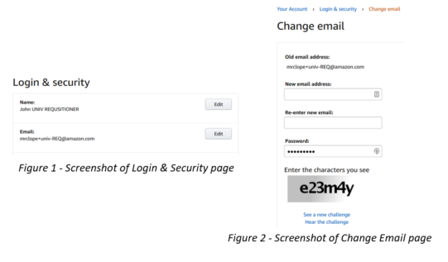

How do I contact Amazon Business Customer Service?  
The best way to contact Amazon Business Customer Service is to follow the steps below:

1. Log into your Amazon Business Account
2. Go to the **Contact Us** link at the bottom of each page
3. Find the area you need assistance with (order, account, etc.)
4. Select Email, Phone or Chat

How do I manage the emails that I receive from Amazon?  
Your email settings can be managed in the Communication Preferences Center (Your Account 🡪Communication Preferences. From here, you can opt out of any marketing emails.

# Activating your Amazon Business account

How do I create my Amazon Business account?From eCUBE you will PunchOut to Amazon Business. From here, you will create an Amazon Account using your YSU email. When you PunchOut to Amazon, if you are prompted to enter a username and password, this means your eCUBE email is associated with a Amazon.com account. You have one of two options:

1. Merge your order history over to the YSU Amazon Account. Only do this if **all of the purchases** on your account are YSU related.
2. Split your current account to a Personal Email. This option is changing your YSU Email to a personal email (i.e. Gmail, Yahoo)

The enrollment process will prompt you to one of the options. From here, all purchases associated with this email will be tied to the centralized YSU Account.

I previously used my @ysu.edu email address to register for a verified Amazon Business account.   
If you previously used your @ysu.eduemail address to register for a verified YSU Amazon Business account, you will need to de-register that account. All previous, stand-alone, Amazon Business accounts will be consolidated under the new, centralized account. Visit <https://amazon.com/gp/b2b/manage/deregister> to complete the de-registration process before accessing Amazon Business for the first time.

**NOTE:** If you are the admin for an account of users and have 5 or more users, you will need to remove the users from your Amazon Business Account first so they can be added to the Centralized YSU Amazon Business account.

# Ordering on Amazon Business

### Below are the step by step directions to placing an order within eCUBE to Amazon Business:

1. From eCUBE, select the Amazon Business tile
2. Once on the Amazon Business page, begin to add items to your cart,
3. Once you are finished adding items to your cart, select the cart icon to view your cart details ‘
4. Once you finished, click the “Proceed to check out” button.
5. Select your shipping options and click the continue button (make sure it is the FREE shipping selection).
6. Select ‘Pay by Invoice’ for your payment method and click the continue button.
7. Finalize your cart and select Your cart is sent and a requisition is created in Jaggaer and you will be notified via email when your cart has been approved
8. When approved, your Order is placed and you will receive an email with the updated shipping details

### How do I access my Order History?

1. PunchOut to eCUBE and hover over your Name. Select Your Orders 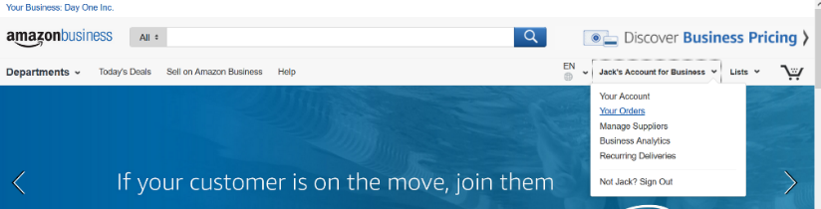
2. From this view, you can track your package, see order details, buy the item again or request a refund.

### How do I get FREE shipping?

Business Prime Shipping provides **FREE 2-day shipping on eligible Prime items,** no matter the order size. For items not eligible for free 2-day shipping, you can receive free standard shipping on eligible orders over $25. Additionally, you will have early access to [lightning deals](https://www.amazon.com/gp/help/customer/display.html?nodeId=201134080) on Amazon Business. Lightning Deals.

### How do I return or exchange an item?

To return or exchange an item, hover over (User)’s Account for Business 🡪 Orders to view your complete order history.

* + Select Return or Replace items at right of product image
  + Select reason for return
  + Print label and authorization
  + Prepare package and return label

Items shipped and sold by Amazon.com orders can be returned within 30 days or receipt of shipment.

If shipped and sold by a 3rd party, policies can vary. If you have questions you can contact the Amazon Business customer service team. For more detail on returns, please visit our [Returns & Refunds](https://www.amazon.com/gp/help/customer/display.html/ref=hp_left_v4_sib?ie=UTF8&nodeId=201819090) page.

### Are there any differences in what I can purchase on Amazon.com when punching out from eCUBE?

Yes, there are some differences that are important to note. Below is a list of some of the features that are not supported when punching out from eCUBE:

**Accessing Amazon from eCUBE does not currently support the following options:**

* Recurring Delivery
* Bundled Items
* Smile Program

**The following cannot currently be purchased through by accessing Amazon from eCUBE:**

* Electronic custom denomination Gift Cards
* Bundled Items
* Software/game downloads
* Digital content
* Kindle Content
* Cell Phones/ Service
* Prime
* Magazines
* Subscriptions

### Are my purchases automatically tax exempt?

YSU will have their tax exempt status applied to eligible purchases from Amazon.com LLC, Amazon Digital Services LLC, Warehouse Deals LLC, Amazon Services LLC or other participating sellers. [Click here](https://www.amazon.com/gp/help/customer/display.html/ref=hp_search_request?__mk_en_US=%C3%85M%C3%85%C5%BD%C3%95%C3%91&help_keywords=refund+tax&search=true&nodeId=201606350&kwHidden=true&sprefix=&locale=en_US) for more information on Amazon’s Tax Exemption Program.

### Why is there tax on my order?

Amazon Tax Exemption is available for qualifying purchases made directly from Amazon.com LLC, Amazon Digital Services LLC, Warehouse Deals LLC, Amazon Services LLC, or other participating sellers and ordered using the Amazon

Business account where you have active exemptions. Tax may still be calculated for items you order from sellers who do not participate in Amazon’s Tax Exemption Program. For more information, please visit our [Tax Exemption Page](https://www.amazon.com/gp/help/customer/display.html/ref=hp_bc_nav?ie=UTF8&nodeId=202107120).

### How do I request a tax refund on Prime items?

If you are incorrectly charged tax on products sold by Amazon.com LLC or Amazon Digital Services, Inc., or sold by other sellers and fulfilled by Amazon, you should reach out to our Tax Exempt team via [tax-exempt@amazon.com](mailto:tax-exempt@amazon.com). Your email you should include

1. Your order number (17 digits in this format: XXX-XXXXXXX-XXXXXXX).
2. Reason for request
3. E-mail address
4. Include that your School is part of the Amazon Tax Exempt Program (ATEP)

You can also visit our [Tax Refund page](https://www.amazon.com/gp/help/customer/display.html/ref=hp_ab_link_n_202036770?ie=UTF8&nodeId=202036770&qid=1530310032&sr=13-2-acs) for more information.

### How do I request a tax refund on 3rd party seller items?

If you purchased your item from a 3rd party seller, you can follow the instructions below to begin the process for a refund.

1. Go to “Your Orders” on Amazon.com.
2. Locate the item that was charged tax and click the “Contact the Seller” button.
3. If the button is not there, they should call the ATEP support line at 1-888-280-9552.
4. Enter the subject as “Tax Exemption Refund Request.”
5. Include the Order Number (17 digits in this format: XXX-XXXXXXX-XXXXXXX) and the amount of tax that was charged.

The seller is required to respond within 72 hours. The seller may ask for some additional information or they may simply issue the refund. For information on how to contact 3rd Party Sellers, see the following [Customer Support page](https://www.amazon.com/gp/help/customer/display.html/ref=hp_ab_link_n_202036770?ie=UTF8&nodeId=202036770&qid=1530310032&sr=13-2-acs).